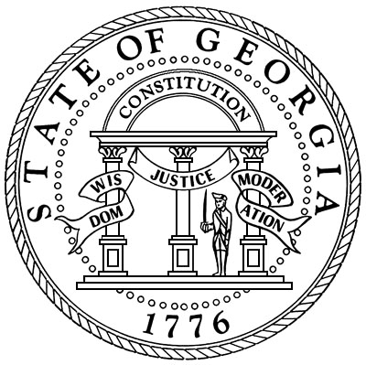

Oglethorpe County Superior Court
Honorable Kelli Paradise Smith
Superior and Juvenile Court Clerk
Post Office Box 68
Lexington, Georgia 30648
(706)743-5731
Fax(706)743-5335
Email: kelli.smith@gsccca.org

UPDATE

By order of Superior Court Judge Harvey Wasserman, jurors will NOT NEED to report for service on Monday October 27. You have been excused and will not need to report until you may receive another summons! Thank you, Kelli Paradise Smith, Clerk of Superior Court.

706-743-5731(questions), kelli.smith@gsccca.org.

