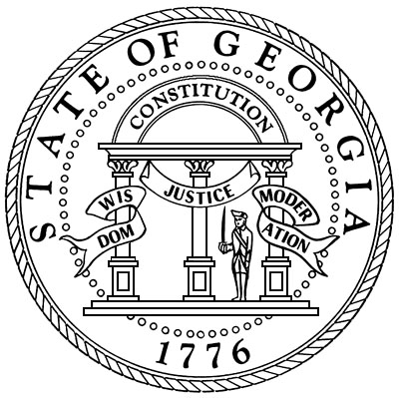

Oglethorpe County Superior Court
Honorable Kelli Paradise Smith
Superior and Juvenile Court Clerk
Post Office Box 68
Lexington, Georgia 30648
(706)743-5731
Fax(706)743-5335
Email: kelli.smith@gsccca.org

If you were summoned for Jury Duty on February 2, at 9:30 a.m., you will now need to report on Tuesday, February 3, at 9:00 a.m. as ordered by Judge Harvey Wasserman. Thank you, Kelli Paradise Smith, Clerk. kelli.smith@gsccca.org 706-743-5731

